HOW TO CREATE A REEL DESIGN USING CANVA
ABSTRACT
Instagram Reels are short videos ranging from 15 to 90 seconds. Video content that is longer than 90 seconds does not qualify as a Reel and is simply referred to as an Instagram video post. Users can access Reels from their feed, the Explore tab, or the Reels tab.

PURPOUSE
A Reel is an Instagram feature that allows users to film or upload video clips for up to 60 seconds that they can edit, sound dub, or add effects to before sharing on the app.
Reels allow brands to develop short-form ads, highlight customer stories in real time, and help better connect with their audiences on Instagram. Reels are personalized based on user interactions. Make sure that you're creating content tailored specifically for your target audience.
Reels invites you to create fun videos to share with your friends or anyone on Instagram. Record and edit 15-second multi-clip videos with audio, effects, and new creative tools.
You can record and edit clips of 15 to 30 seconds, adding audio, effects, and creative tools you desire. You can share Reels with anybody on Instagram. You can share Reels straight to your feed.
With up to 90 seconds of video it is easy to share an engaging, detailed video with your audience. Using trending video content and audio to tell your story is a great way to increase engagement and reach the right audience.
our Instagram Reels views can also say a lot about how well your Reels content is performing. The more views you achieve, the more reach you can count on. Your videos will make it to new users, introducing them to your account and your brand.

EMPATHY MAP

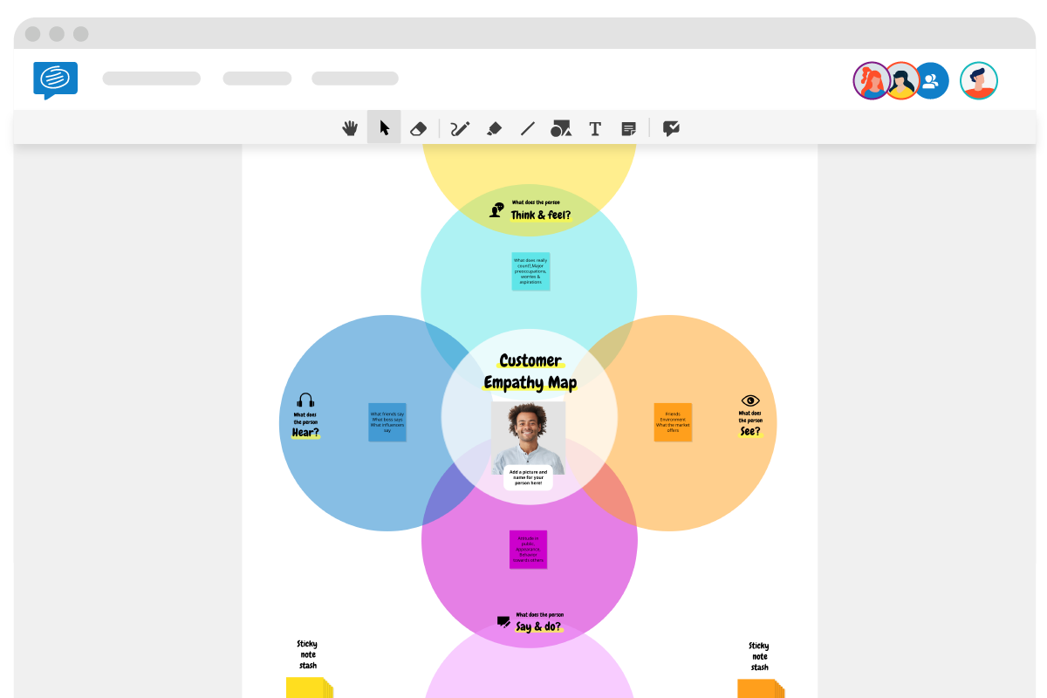

BRAIN STROMING

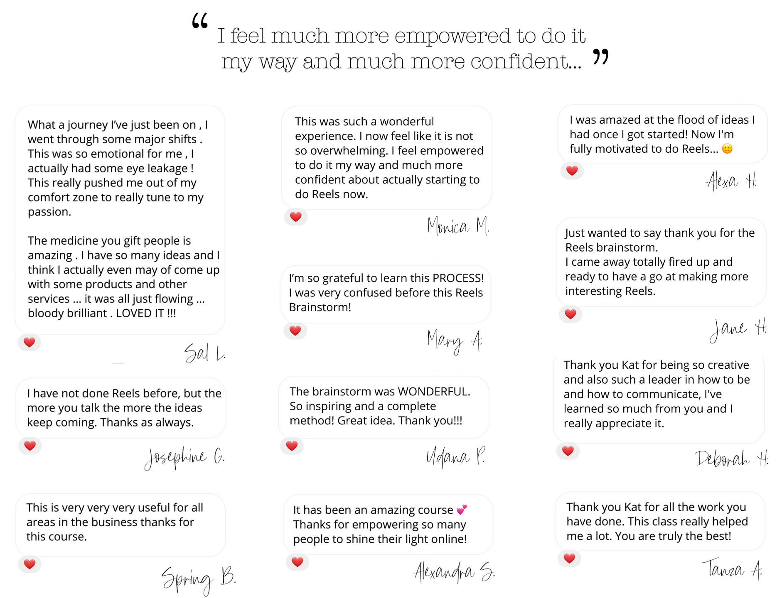

ADVANTAGES
- In addition to providing a creative outlet, Instagram Reels can also be a great way to drive traffic to a user's profile.
- When someone discovers a Reel they enjoy, they may be more likely to check out the rest of the user's content.
- This can lead to an increase in followers and engagement on the user's profile.
CONCLUSION
There's still a long way to go to ensure Instagram Reels offers everything businesses need to reach their audience in a way that can result in sales. But early adoption of Reels as a content type could be great if you're trying to reach new audiences to grow brand awareness.

